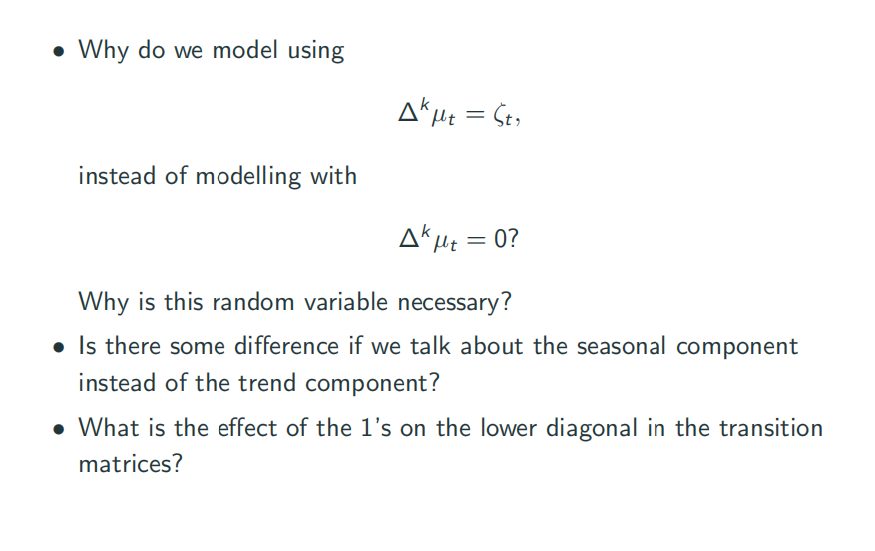

1 Because data is not perfect. If constant is perfectly form the polynomial, then we can have 0 constant. But in practice the data cannot be perfect, so we need to have noise.

2 Because we want to take record of previous vector.